SIMULATION AND EVALUATION OF A DRONE RELATED VIBRATION CONTROL MECHANISM
AUTHORS
KR Kanish Koushik 2362867
S Ganesh Reddy 2362868s
Sidharth Sivan 2362869
Mukhunthan AR 2362870

ABSTRACT
Unmanned Aerial Vehicles (UAVs), commonly referred to as drones, have become an important part of modern technology. They are widely used in applications such as surveillance, aerial photography, agriculture monitoring, disaster management, delivery systems, and infrastructure inspection. Despite their advantages, drones face several technical challenges that affect their performance and reliability. One of the most important issues is vibration generated from motors, propellers, structural components, and environmental disturbances such as wind.
Excessive vibration can negatively impact the stability of a drone and reduce the accuracy of onboard sensors and cameras. It can also cause structural fatigue and reduce the lifespan of mechanical components. Therefore, vibration control plays a crucial role in improving the performance and reliability of drone systems.
This project focuses on the simulation and evaluation of a vibration control mechanism for drones. A simulation-based model is developed to analyze vibration behavior and to test control mechanisms that help reduce oscillations in the system. By using computational modeling and analysis, the project demonstrates how vibration control mechanisms can enhance drone stability and system performance. The results obtained from simulation show that the proposed mechanism significantly reduces vibration amplitude and improves system response.

INTRODUCTION
Drones have rapidly evolved over the last decade and are now used in many industries including agriculture, logistics, defense, filmmaking, and environmental monitoring. Their ability to access difficult or dangerous locations makes them extremely valuable tools. However, the performance of drones depends heavily on their ability to maintain stable flight conditions.
A drone typically consists of several key components including motors, propellers, sensors, controllers, and a structural frame. The motors and propellers generate thrust that allows the drone to lift off and maneuver in the air. However, these rotating components also introduce vibrations into the system. These vibrations can propagate through the drone’s structure and affect sensors such as gyroscopes, accelerometers, cameras, and GPS modules.
When vibrations become excessive, they can cause inaccurate sensor readings, unstable flight behavior, and reduced image quality. In aerial photography, for example, vibration can cause blurry images or shaky video footage. Similarly, in autonomous navigation systems, vibration can affect sensor accuracy and lead to incorrect control decisions.
To address these issues, engineers design vibration control mechanisms that reduce unwanted oscillations. Simulation tools play a major role in evaluating such systems before implementing them in real hardware. Through simulation, researchers can analyze system behavior under various conditions, test control strategies, and optimize system parameters.
This project uses simulation techniques to study vibration effects in drone systems and evaluate the effectiveness of vibration control mechanisms.

OBJECTIVES
The primary objective of this project is to analyze and evaluate vibration control techniques in drone systems using simulation methods. The specific objectives include:
- Understanding the sources of vibration in drone systems.
- Developing a mathematical and simulation model representing drone dynamics.
- Introducing vibration disturbances into the simulation model.
- Designing and implementing a control mechanism to reduce vibrations.
- Analyzing system performance before and after applying vibration control.
- Evaluating the effectiveness of the proposed mechanism through simulation results.
By achieving these objectives, the project demonstrates how vibration control strategies can enhance the stability and performance of drone systems.

BACKGROUND AND THEORY
Vibration is defined as the oscillatory motion of a mechanical system around an equilibrium position. In drones, vibration occurs due to rotating components such as motors and propellers, structural flexibility, and environmental disturbances.
There are two main types of vibration that can occur in drone systems: forced vibration and free vibration. Forced vibration occurs when an external force such as motor rotation continuously excites the system. Free vibration occurs when the system oscillates naturally after being disturbed.
In drone systems, forced vibration is the most common type because motors continuously generate rotational forces. If these vibrations are not controlled, they can propagate through the frame of the drone and affect sensitive components.
Engineers use several techniques to reduce vibrations, including passive damping methods and active control methods. Passive damping involves using materials or mechanical structures that absorb vibration energy. Active control methods involve sensors and controllers that detect vibration and apply corrective actions to reduce oscillations.
Simulation plays a critical role in studying vibration behavior. By modeling the system mathematically and analyzing its response, engineers can predict how the system will behave under different conditions. This helps in designing effective control mechanisms.

SYSTEM ARCHITECTURE
The system developed in this project consists of multiple components that work together to simulate drone vibration behavior and evaluate control mechanisms.
The main components of the system include:
- Drone Dynamic Model:
This model represents the physical behavior of the drone including mass, inertia, thrust generation, and motion dynamics.
- Vibration Disturbance Model:
This component introduces disturbances into the system to simulate vibrations caused by motors and propellers.
- Control Mechanism:
A controller is implemented to reduce vibration amplitude and stabilize the system.
- Simulation Environment:
The simulation environment provides tools to model system behavior, visualize results, and analyze system response.
- Performance Evaluation Module:
This module evaluates the effectiveness of the vibration control mechanism by analyzing system response graphs and performance metrics.
Together, these components form a complete simulation framework for analyzing drone vibration control.

METHODOLOGY
The methodology used in this project follows several systematic steps.
- Step 1: Drone Modeling A mathematical representation of the drone system is created. This includes parameters such as mass, inertia, thrust forces, and aerodynamic effects. These parameters define how the drone behaves during motion.
- Step 2: Vibration Modeling Vibration disturbances are introduced into the system to simulate real-world effects. These disturbances represent forces generated by motors and propellers.
- Step 3: Control Design A control mechanism is implemented to reduce vibration amplitude. The controller monitors system behavior and applies corrective actions to stabilize the system.
- Step 4: Simulation The entire system model is simulated using computational tools. Different scenarios are tested to observe how the drone behaves under vibration disturbances.
- Step 5: Performance Evaluation The results obtained from simulation are analyzed to evaluate the effectiveness of the vibration control mechanism.

SIMULATION RESULTS AND ANALYSIS

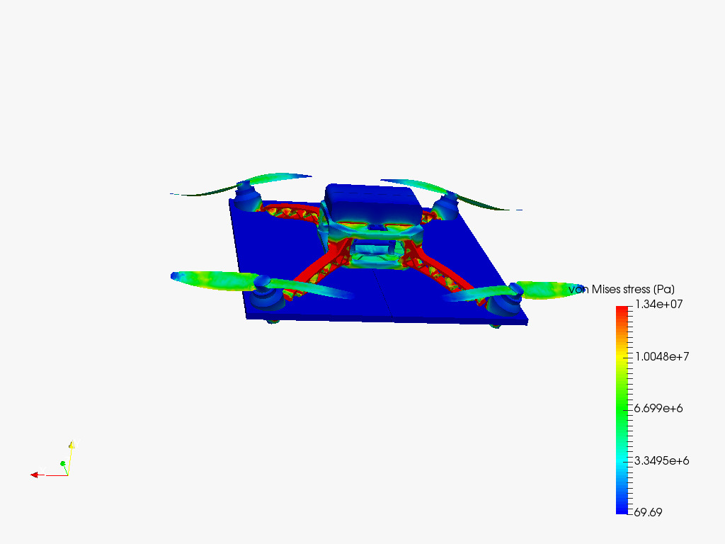
Body Vibration Area
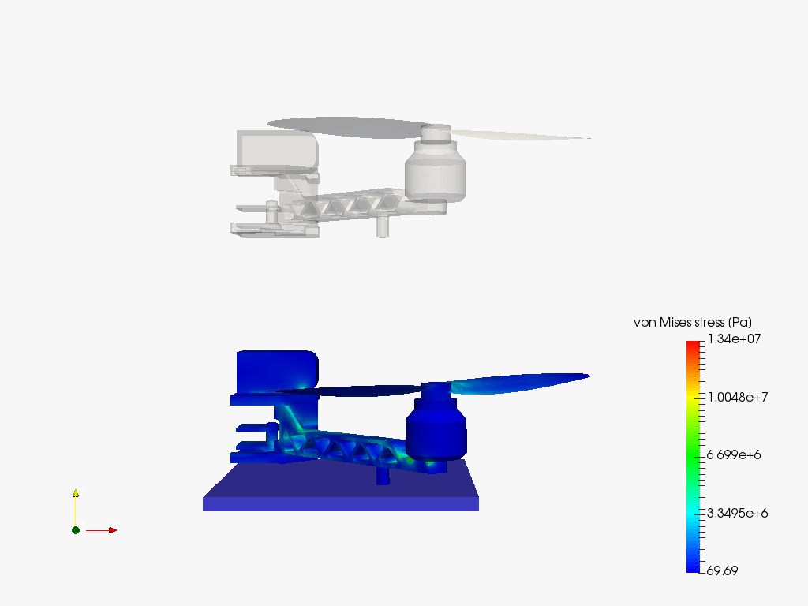
Body Vibration For Motor End
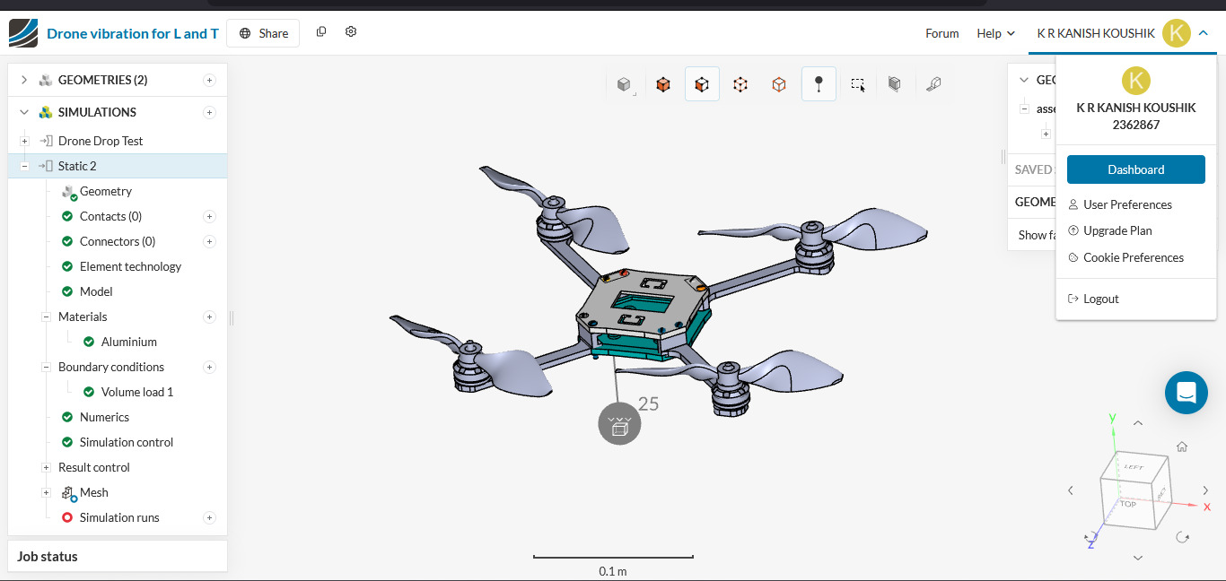
Drone Model
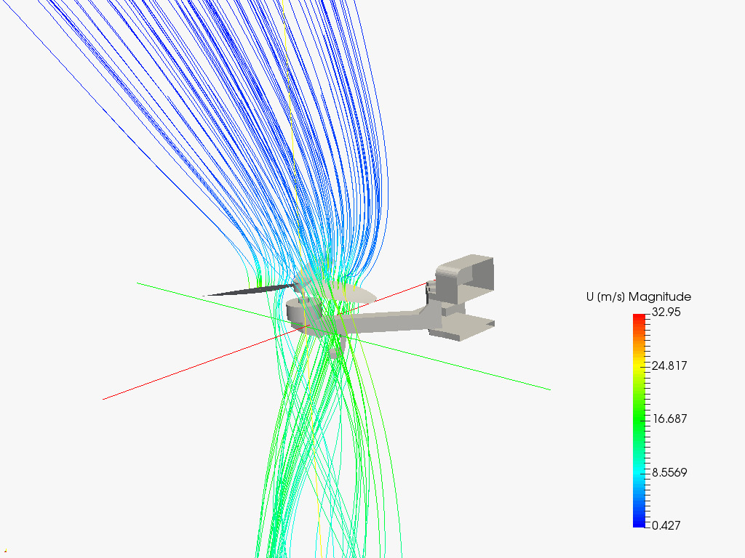
Drone Air Control When its on Flight And Vibrations
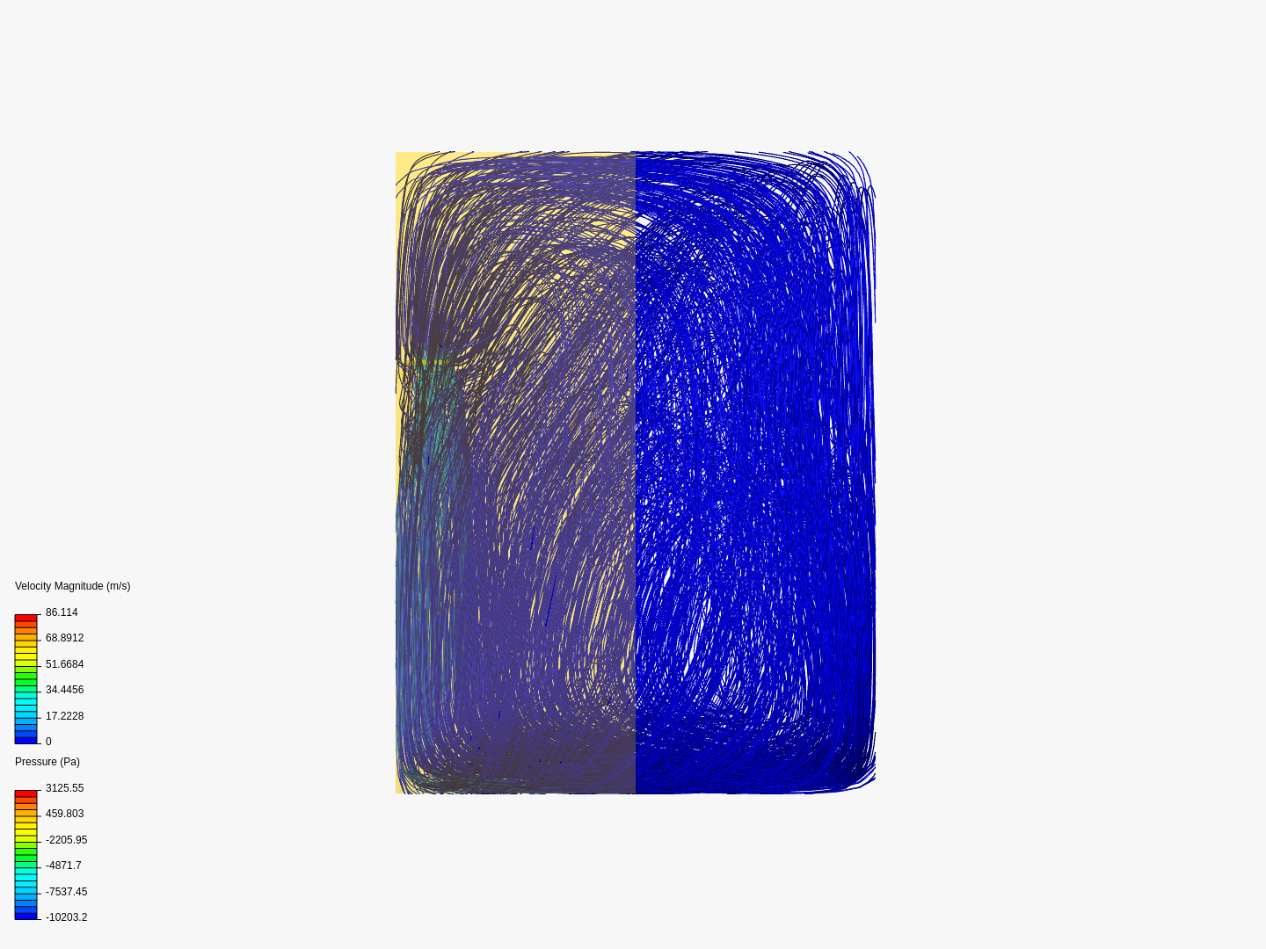
Air Momentum In the Closed Box
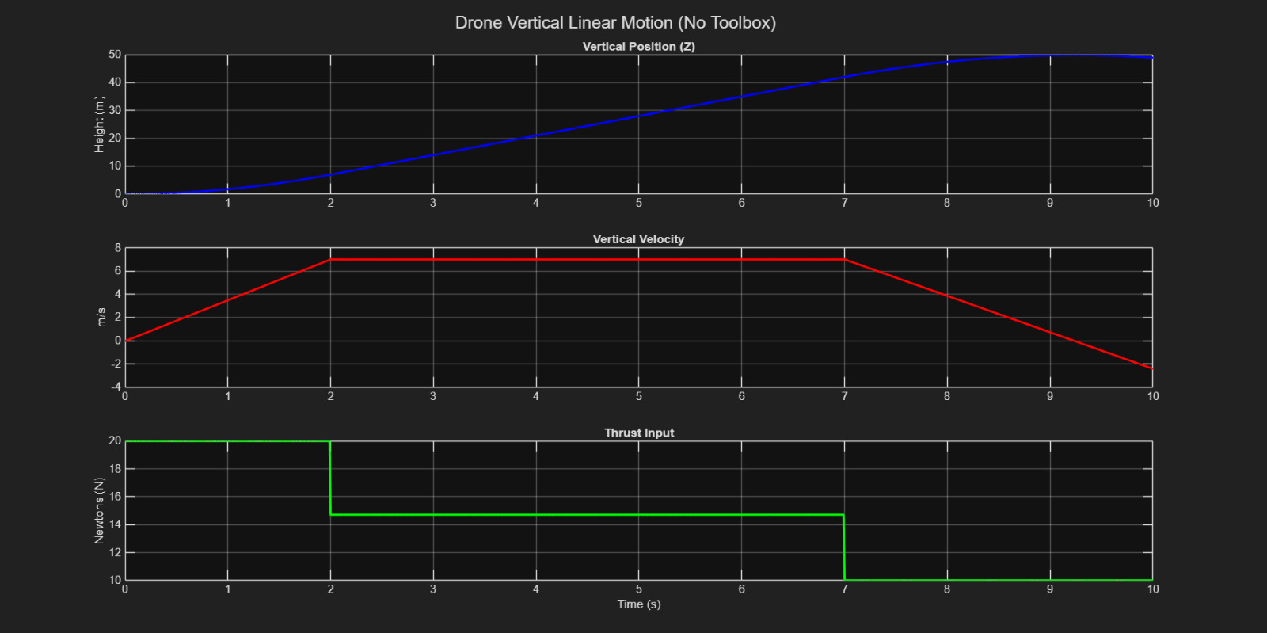
Drone Vertical Motion Linear

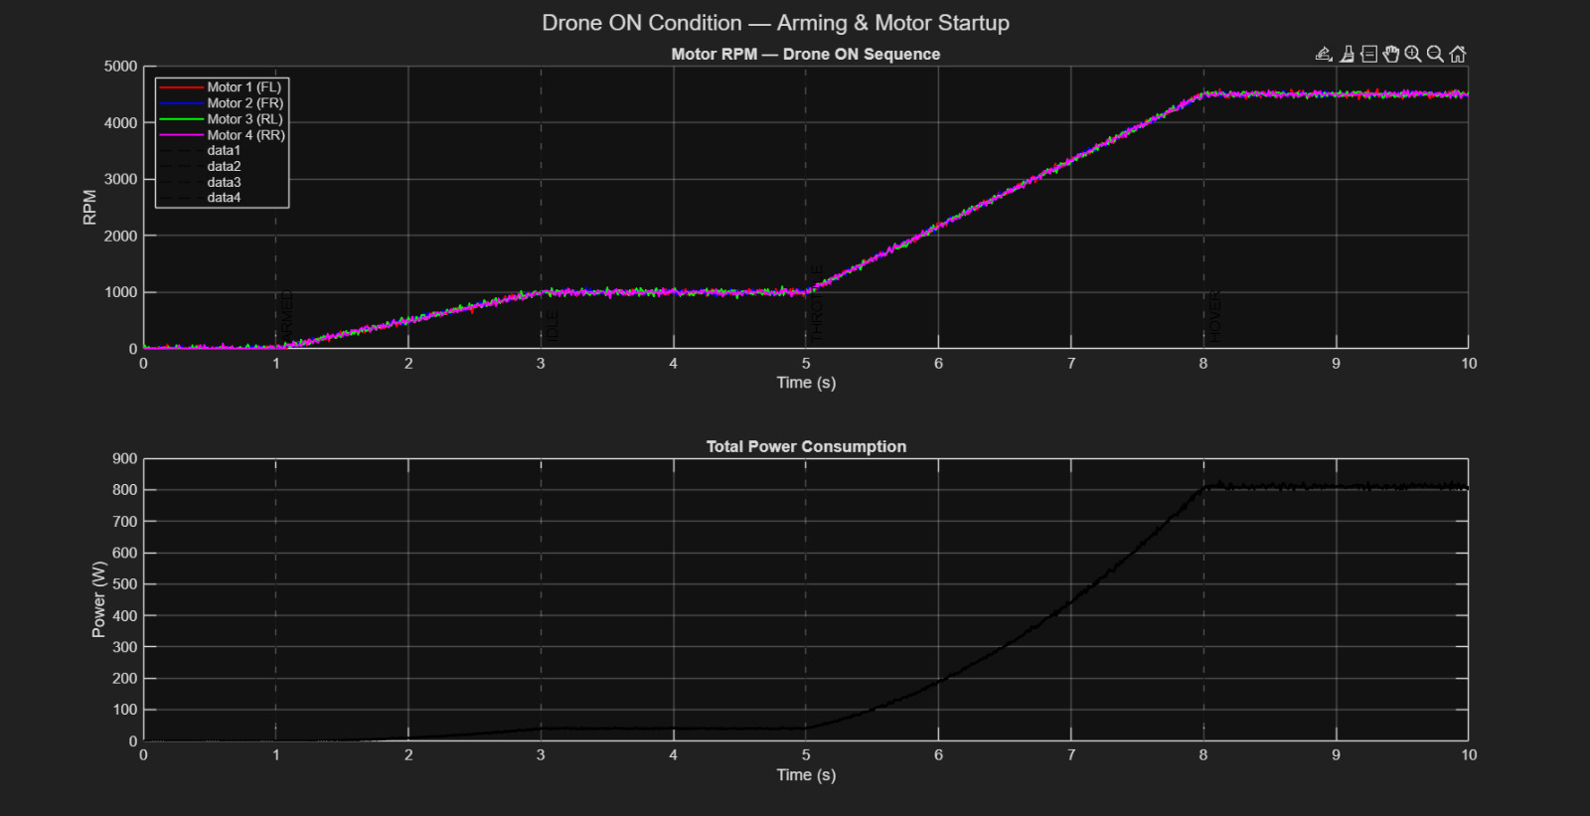
Motor Aiming And Start up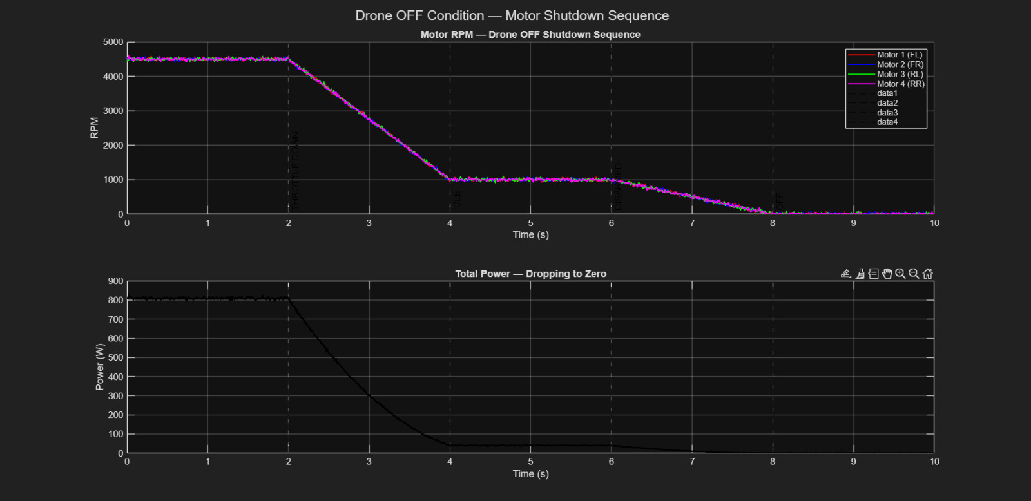
Motor Shutdown Sequence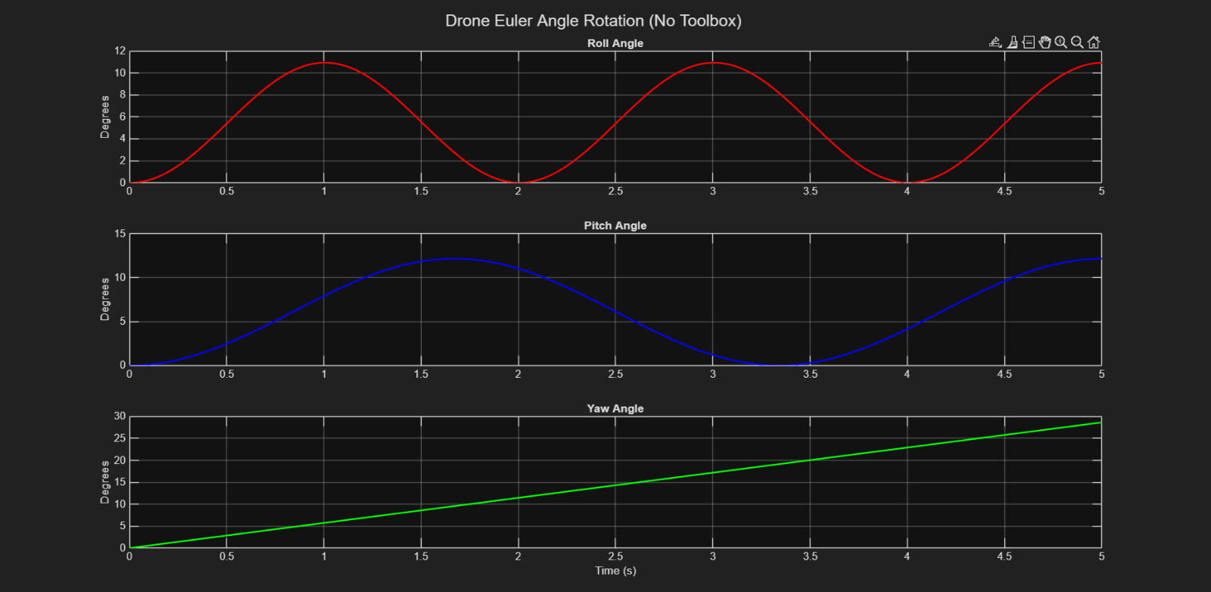
Drone Euler Angle Rotation

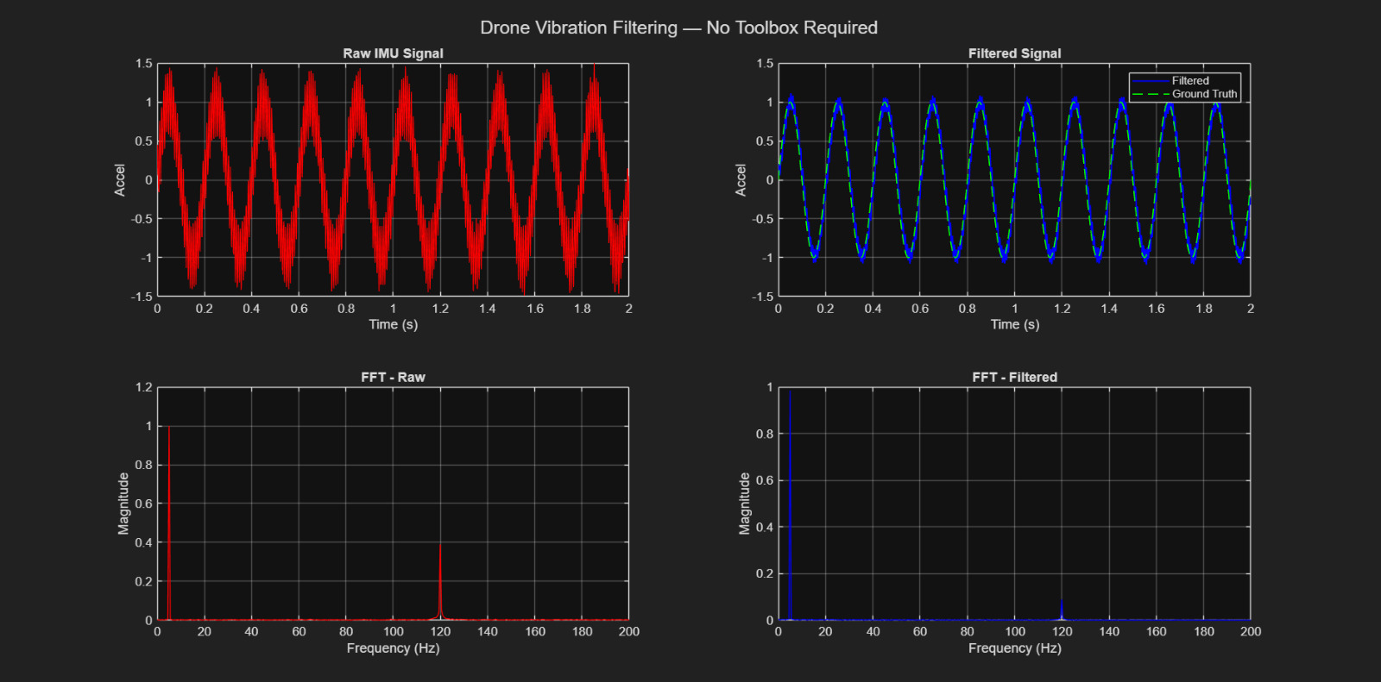
Drone Vibration Filtering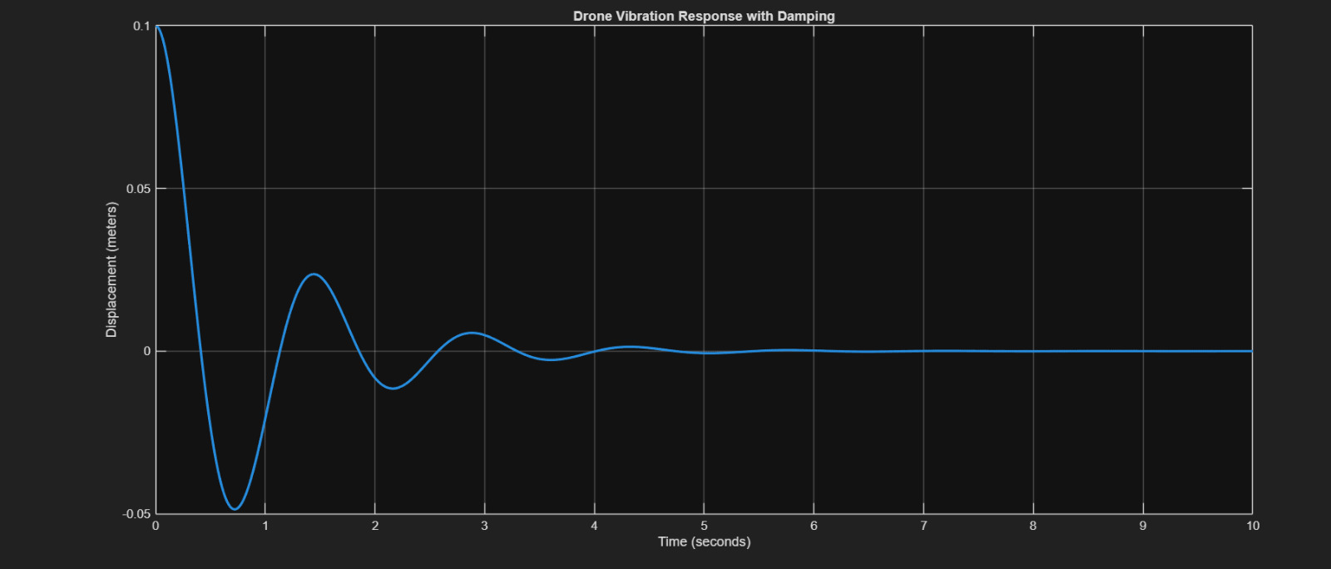
Drone Vibration Response File

ADVANTAGES
The proposed vibration control mechanism provides several benefits:
- Improved stability of the drone during flight.
- Reduction in vibration amplitude.
- Improved accuracy of sensors and cameras.
- Increased reliability and safety of drone operations.
- Ability to test and optimize systems through simulation before hardware implementation.

LIMITATIONS
Although the simulation results demonstrate the effectiveness of the vibration control mechanism, there are some limitations.
Simulation models may not fully represent real-world conditions.
Environmental factors such as wind turbulence can introduce additional disturbances.
Hardware implementation is required to validate the results obtained from simulation.
More advanced control algorithms may further improve system performance.

FUTURE WORK
Future research can focus on improving and extending this project in several ways.
Implementing the vibration control mechanism on an actual drone platform.
Integrating advanced control algorithms such as adaptive or intelligent control systems.
Using machine learning techniques to predict and compensate for vibration disturbances.
Testing the system under different environmental conditions.
Improving the simulation model to include more realistic aerodynamic effects.

CONCLUSION
This project presented a simulation-based study for evaluating vibration control mechanisms in drone systems. By modeling drone dynamics and introducing vibration disturbances into the system, the project demonstrated how control strategies can improve system stability.
The results obtained from simulation show that vibration control mechanisms significantly reduce oscillations and improve system response. These improvements lead to better flight stability, improved sensor accuracy, and enhanced reliability of drone operations.
The study highlights the importance of simulation tools in designing and evaluating drone control systems before implementing them in real hardware. Future work can further enhance the system by implementing the proposed mechanism on actual drone platforms.

REFERENCES
- Modern Control Engineering, 5th Edition, Prentice Hall, 2010.
- Feedback Control of Dynamic Systems, Pearson Education, 2015.
- MATLAB Documentation, The MathWorks Inc.
Available: https://www.mathworks.com/help/
- Simulink Documentation, The MathWorks Inc.
Available: https://www.mathworks.com/products/simulink.html
- IEEE Xplore Digital Library.
Available: https://ieeexplore.ieee.org
- NASA.
“Introduction to Unmanned Aircraft Systems.”
Available: https://www.nasa.gov

